**Batch: A-3 Roll No.: 16010122104**

**Experiment / assignment / tutorial No. 9**

**Grade: AA / AB / BB / BC / CC / CD /DD**

**Signature of the Staff In-charge with date**

**Experiment No.:9**

|  |
| --- |
| **TITLE: Study and configure DHCP & DNS protocol using Cisco Packet tracer** |

**AIM:** To study and configure **DHCP/DNS** protocol using Cisco Packet tracer

**_____________________________________________________________________________**

**Expected Outcome of Experiment:**

**CO:**

**_____________________________________________________________________________**

**Books/ Journals/ Websites referred:**

1. A. S. Tanenbaum, “Computer Networks”, Pearson Education, Fourth Edition
2. B. A. Forouzan, “Data Communications and Networking”, TMH, Fourth Edition

_____________________________________________________________________________

**Pre Lab/ Prior Concepts:**

IPv4 Addressing, Subnetting, Link State Protocol, Router configuration Commands

**_____________________________________________________________________________**

**New Concepts to be learned: DHCP/DNS** Protocol and its configuration.

**_____________________________________________________________________________**

**THEORY:**

Dynamic Host Configuration Protocol (DHCP) is a client-server protocol designed to automatically assign an Internet Protocol (IP) address and other network configuration details, such as the subnet mask, default gateway, and DNS servers, to devices on a network. DHCP enables devices, whether a laptop, smartphone, or IoT device, to connect to the network without manual configuration by automatically providing the necessary IP details. This process simplifies the management of IP addresses within networks, especially when devices frequently connect and disconnect.

On the Internet, devices use IP addresses to identify and communicate with one another. However, humans find it easier to use domain names, like `example.com`, rather than numerical IP addresses such as `192.0.2.1`. To facilitate this, the Domain Name System (DNS) is used. DNS translates user-friendly domain names into IP addresses, allowing devices to locate and connect to each other based on recognizable names instead of numerical addresses. For example, a DNS service, like Amazon Route 53, operates as a globally distributed system that maps human-readable names to IP addresses, much like a digital phone book. DNS servers respond to queries by providing the correct IP address for a given domain name, directing the user's browser to the appropriate server. This process ensures users can reach the desired website or service without needing to know or remember specific IP addresses.

**IMPLEMENTATION:**

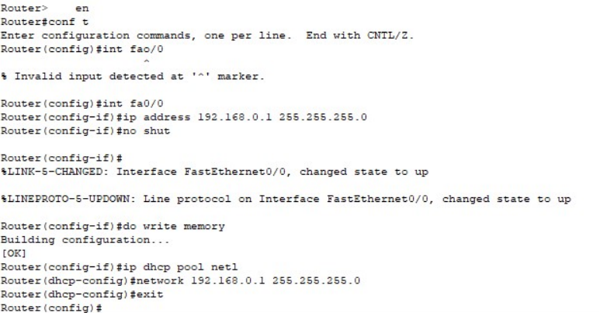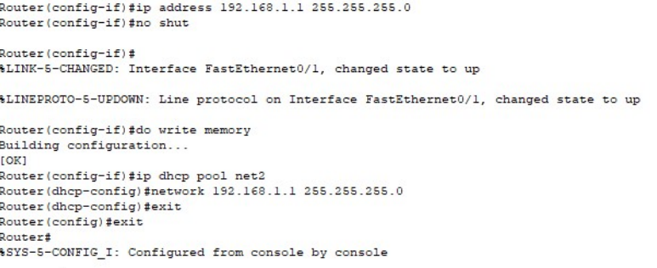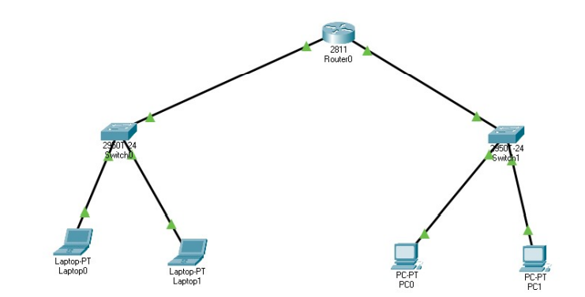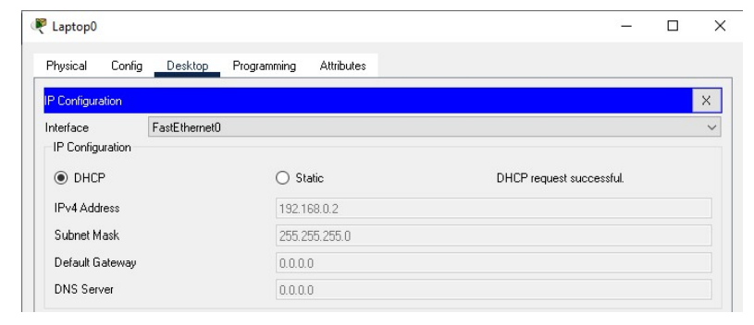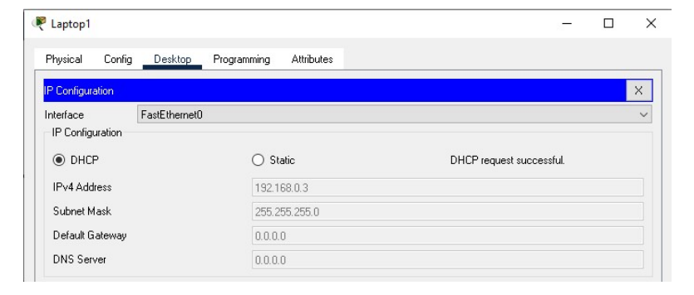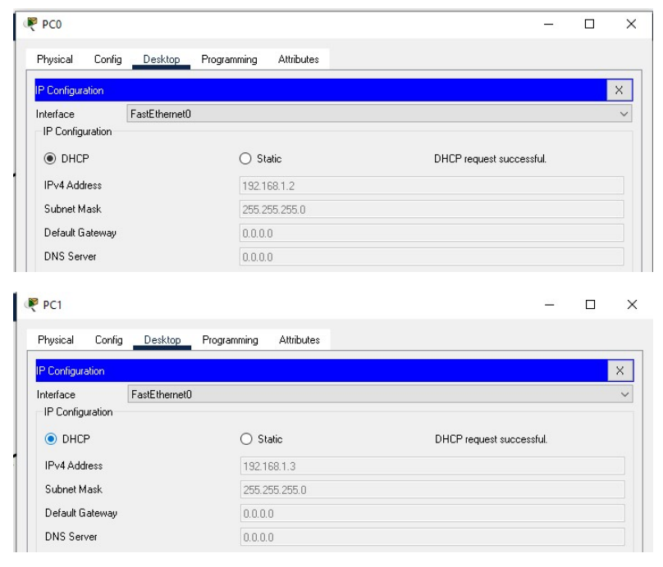

**CONCLUSION:** We successfully studied and configured DHCP/DNS protocol using Cisco Packet tracer.

**Date: 11/11/2024 Signature of faculty in-charge**